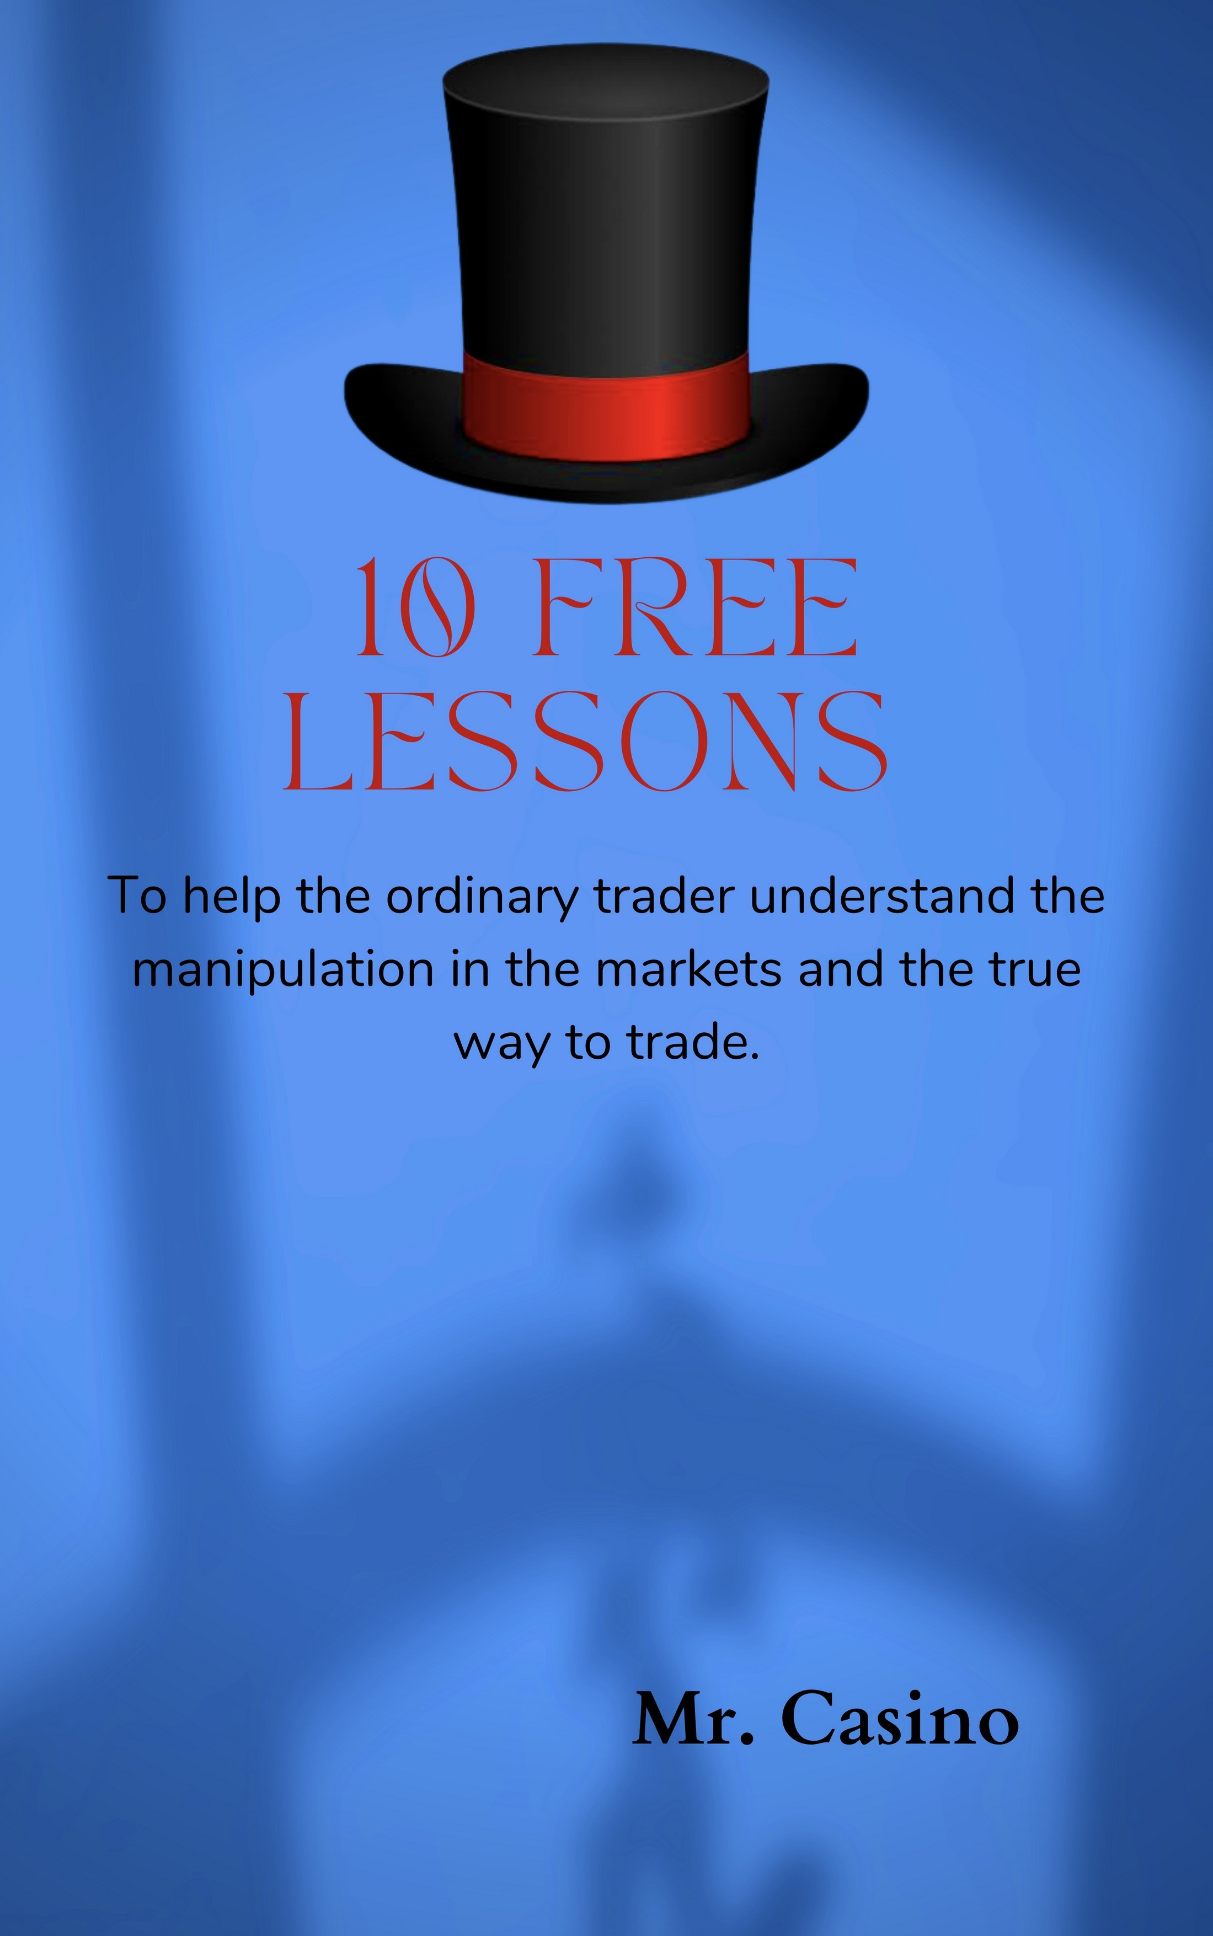

MR.CASINO

rinsingdabanksforex
The truth of trading is actually quite sad. Unfortunately when most people get into trading they have unreal expectations and their negative emotions cause them to fail. Paired alongside the fact that the markets are manipulated- very much so by the "big players" (banks and institutions).
And there is alot misinformation out there - the banks don't want you to know about the high risk to reward trade possibilities for it drastically puts the odds in your favour. But hey your here now so it's time to change that!
These lessons have been structured in a step by step approach for anyone looking to trade, beginners or experienced traders, for it is a unique style of trading and will show you a whole new perspective. Of course I have kept these lessons to the basics - there is alot more to be covered but the information provided is enough for one to make the transition into thinking like a true trader and you will definitely see progress. Without further ado... here are only 10 lessons you need.

LESSON:1
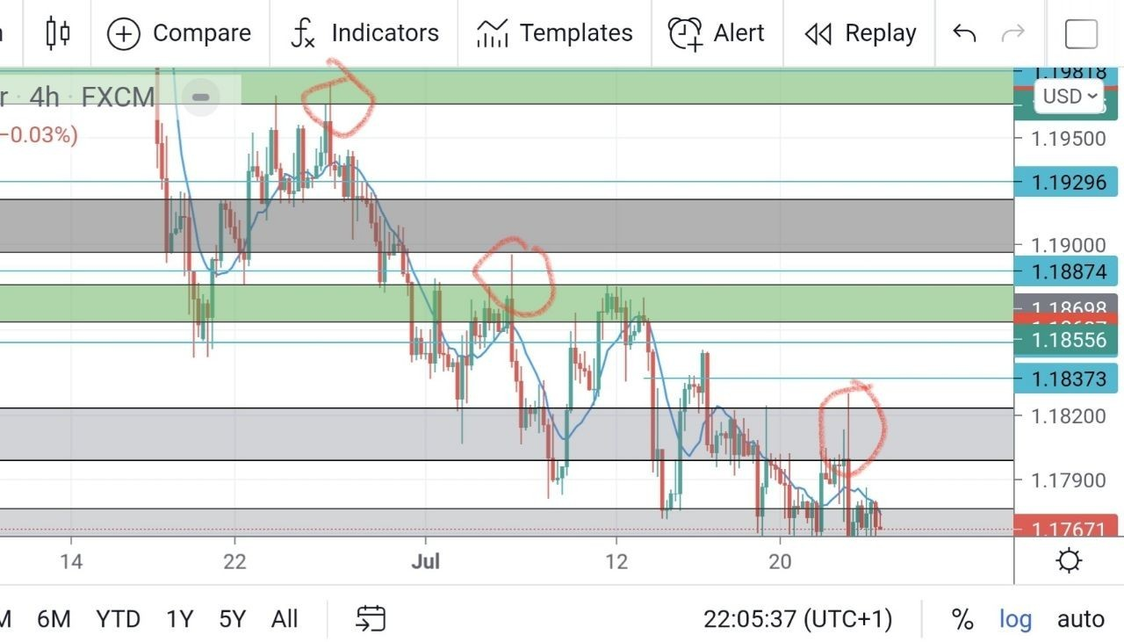
Price MUST break and retest every zone before moving to a further price point.
See price was going down on EURUSD. If it went right through two support zones without retest we KNOW 100% that price will come back to that price point again.
Here we see a normal down trend but it's very good becouse of all the retest so we can expect price to go down more.The circle part is another part price broke though two zones I call it SMASHED and then before going down had to retest.
This is a fundamental rule of trading and should not be neglected even for experienced traders.
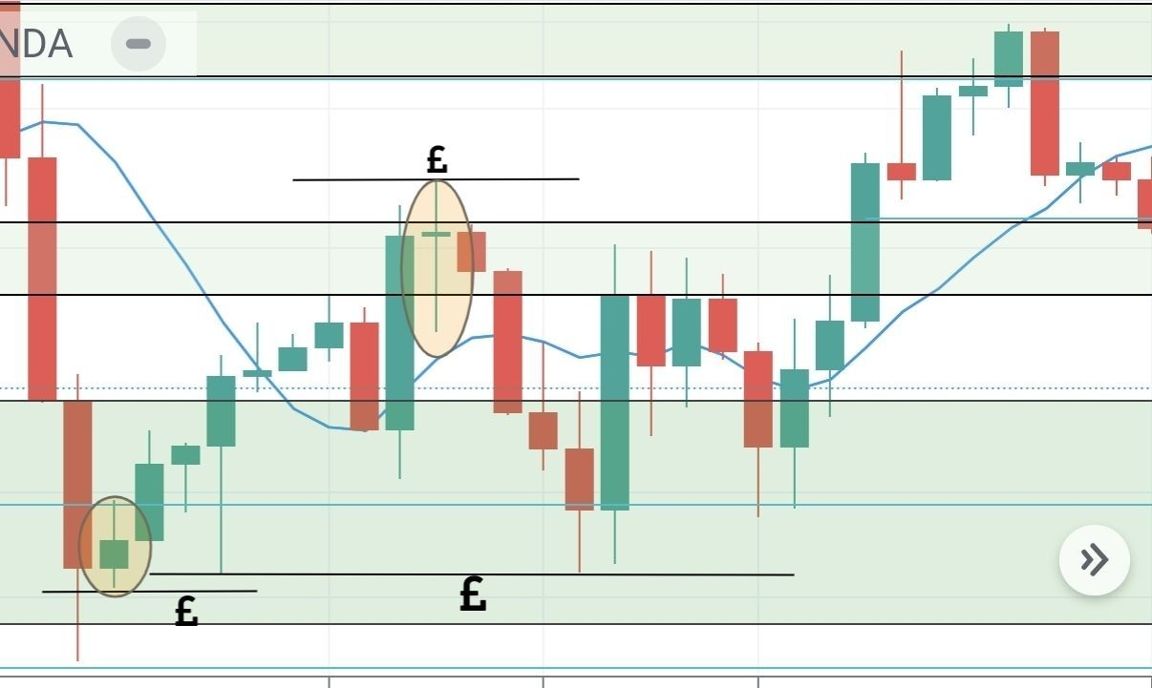

LESSON:02

Liquidity

Each £ sign represents where the normal traders (who see the doji and sell/buy) would put their stop loss.This is liquidity sure you can make money using dojis , double tops/ bottoms etc but if we see this play out in the markets we know the market makers (big players who move the markets) will hunt these stops before moving to the next price point.
Using this technique we can determine where price will go in the future. After market structure this is the most fundamental lesson in as I will call TRUE trading.
Look at what price does next.
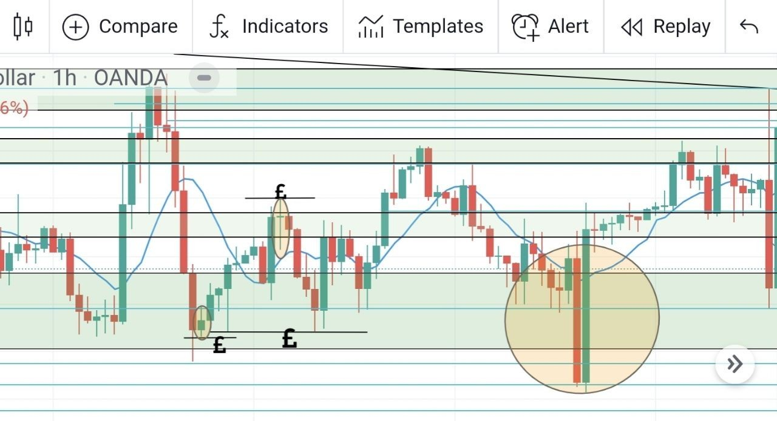
First price went above the dojis to clear out all the stop loss. All the retail traders now looked to buy the "breakout" and then price reversed and took all of them out.
Look where price went to before reversing up in a MASSIVE candle. Right after taking out the liquidity market on the chart. INSANE right?
Open your eyes retail traders this is the true way to trade that no one wants you to know about [19:09].

LESSON:03

Institutional supply and demand

Before starting this lesson we must first understand how the market makers (banks and institutions) make price move.
If they want to move price up all they have to do is place a large amount of buy orders and price will move in their direction. However in order to buy you must have sellers which is why retail. trading is so popular - the banks want you to trade in the opposite direction to them so they may take your liquidity to move price.
One theme they use often is called orderblocks. Memorise this term becouse it will come again and again! And using this we find our true zones (remember market structure is first but institutional zones are where you can expect to see big moves).
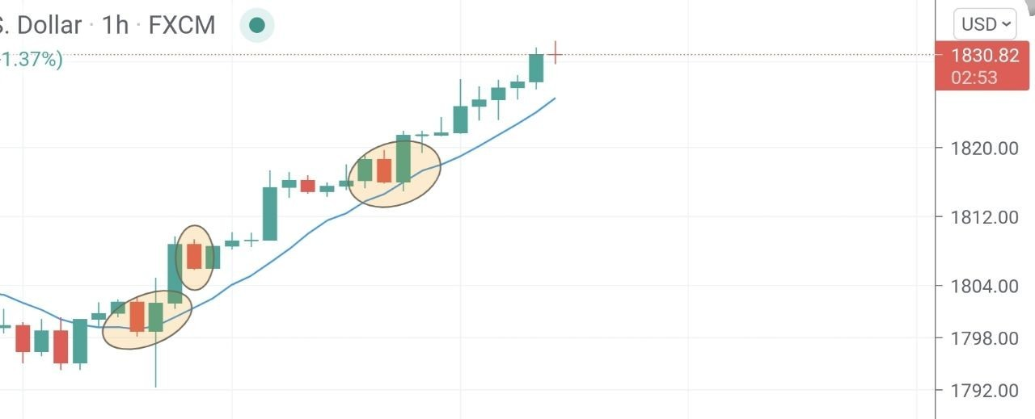
Each circle shows a orderblock. This is where you will truly understand the extent to which the markets are manipulated its totally crazy honestly!
We know institutions want to push price up on gold - we had two confirmations liquidity was taken (yesterday's double bottom on gold) and we know price will go higher as we have liquidity above.
Remember banks can't just indefinitely move price up if no one is selling. So what do they do? They place sell orders (large enough to move price down a little) and then they buy at the discounted price shooting price up!
In other words.. they "hack" the markets into producing sells JUST so they can buy.
However here's the thing... What about all the sell orders they used to push price down? They are in negative so we can KNOW price will come back to this point so the banks can close their sell orders (at a slight loss or breakeven)
I know this may seem confusing especially for beginners and I wish I could explain more in detail but it will be too long.
All you need to know is how to find and identify orderblocks (a odd sell candle in the middle of an uptrend or an odd buy candle in the middle of and uptrend) I would only recommend using 4hr and 1hr time frames to find these at least till your more comfortable with the concept.
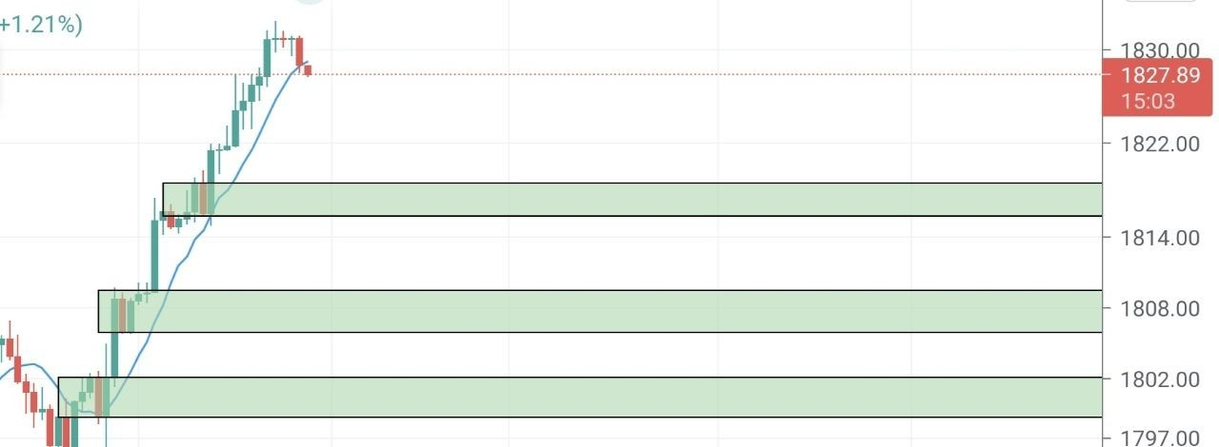
This is how you would draw out your zone.J ust the body of the candle (no wicks) as this is where the orders are concentrated.Just watch and see how price will constantly react of these zones. Forget your normal retail support and resistance (although it can be a good tool its not as accurate).
I'm using a new example (on gold 1hr) so that in the coming weeks you can see live how price reacts from these zones. They are very accurate in comparison to normal retail zones.
You see an orderblock? Mark it out for this is now an institutional zone and price will react from here in the future.

LESSON:04

Institutional candles (or FU candles)

Look at the above example. We see a doji (a possible sign of reversal) and this is where the institutions induced retail traders to an early short position. See the next candle? It wicked above the doji (manipulation) hit all their stoploss and then bam! Price dropped but only after liquidity was taken.
This is called an FU candle you must have two confirmations in order for it to be valid.
- Liquidity is taken (doesn't have to be a doji can be double tops/ bottoms anywhere where retail stoplosses are)
- After taking liquidity the same candle breaks structure
This is a very strong confirmation and you can see the direction the banks are trading and trade along with them.
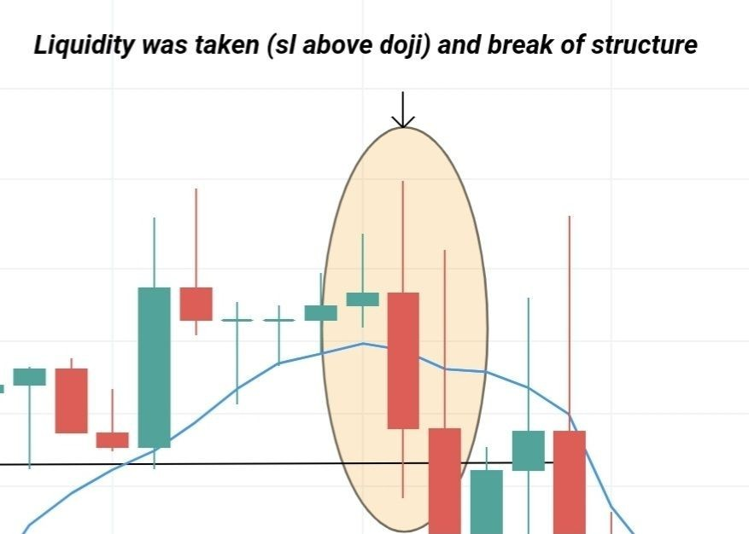
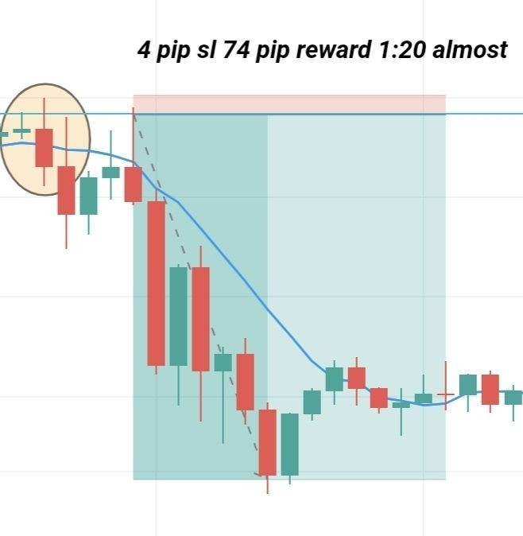
How do we
find setups using this pattern? It comes on
all
timeframes (although I wouldn't recommend using less than 30 min timefram unless trading gold which is more manipulated than normal forex pairs).
Simple. We mark out the 50% (of the wick that took liquidity) and we place out buy / sell limits with the stop loss above the wick. The smaller the timeframe the more smaller stop loss you will have (this example is on the 1hr tf on EU).
Using this you can find some beautiful sniper entry trades with very big risk to reward.
Of course with any strategy this isn't a 100% win rate lol but becouse you can find amazing RR ratios one win far outweighs any losses.
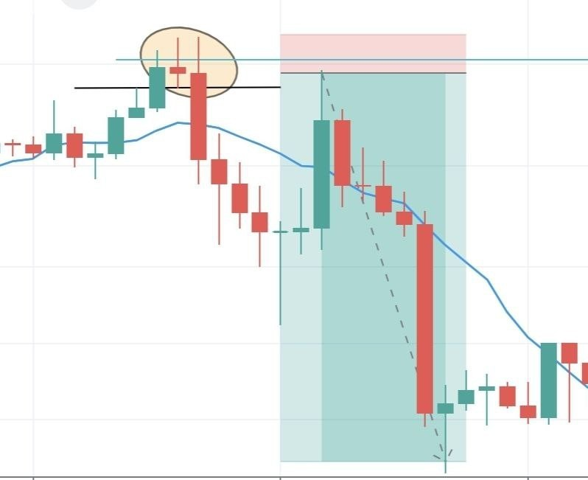
Sometimes price will react from the start of the wick not the middle 50% (showed by the blue line) as in this example. However personally I only take 50% trades to find smaller stop losses.
That said you can still find great risk to reward (compared to retail traders) for example here we have a 8 pip stoploss for a 80 pip reward (1:10).
Don't worry if you don't understand this fully yet I'm posting this early today so you can spend the day backtesting this pattern and becoming familiar with it.
Trust me your going to see this everywhere in ALL markets and as this is a candlestick formation (well only for us institutional traders) its very easy to see you don't need to know alot about trading to start using this to find beautiful setups.
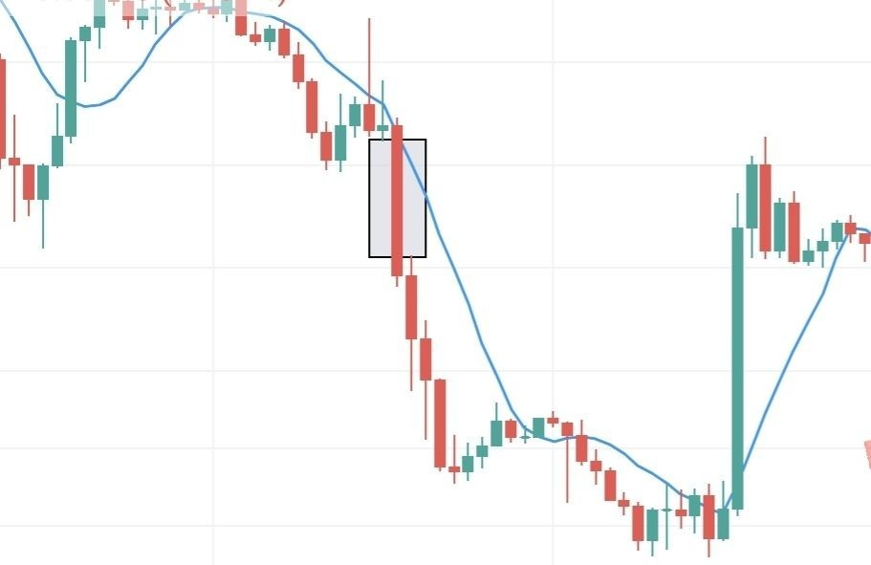

LESSON:05

Imbalances

What is an imbalance? In basic terms any place where price suddenly smashed through price without it being tested first.
For example look at the marked out grey area. We see the imbalance a pure bearish candle with no retest in that area. We draw out our area from just the part where price hasn't been tested (from the previous candle close to the next candle open) that is an imbalance.
Look how perfectly price reacted to fill in this imbalance. It can be used as a way to determine where the market is going next or we can find entries using just the imbalance area.
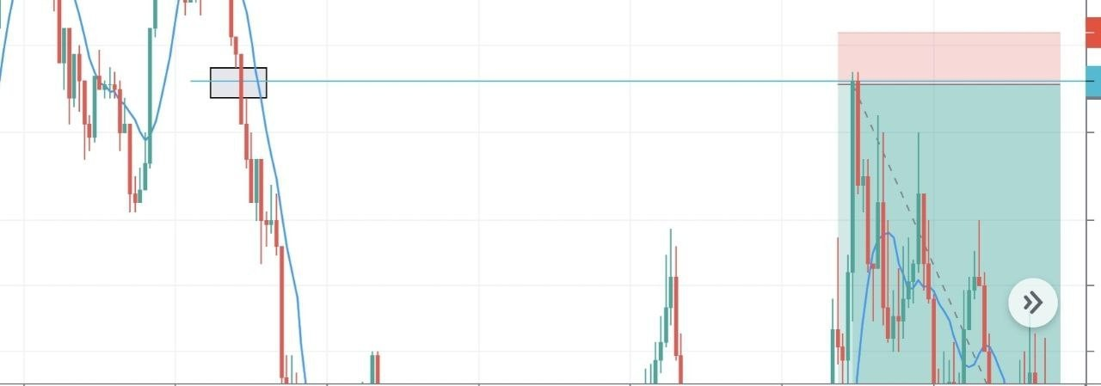
This is an example on the 1 min time frame. The grey area is the imbalance area! See how that was "untested" I.e an imbalance? And look how perfectly price reacted to fill in this imbalance and then drop in the other direction.
Keep in mind this is the 1m timeframe! This particular trade would have a one pip stop loss! Crazy right? But here I am showing you the market hacks lol. It goes so much deeper as always but keeping things brief here.
You won't find this technique on YouTube I assure you. Maybe a few videos on imbalances but not how to use them to find sniper entries.
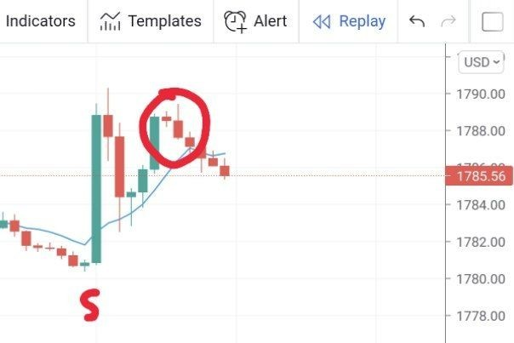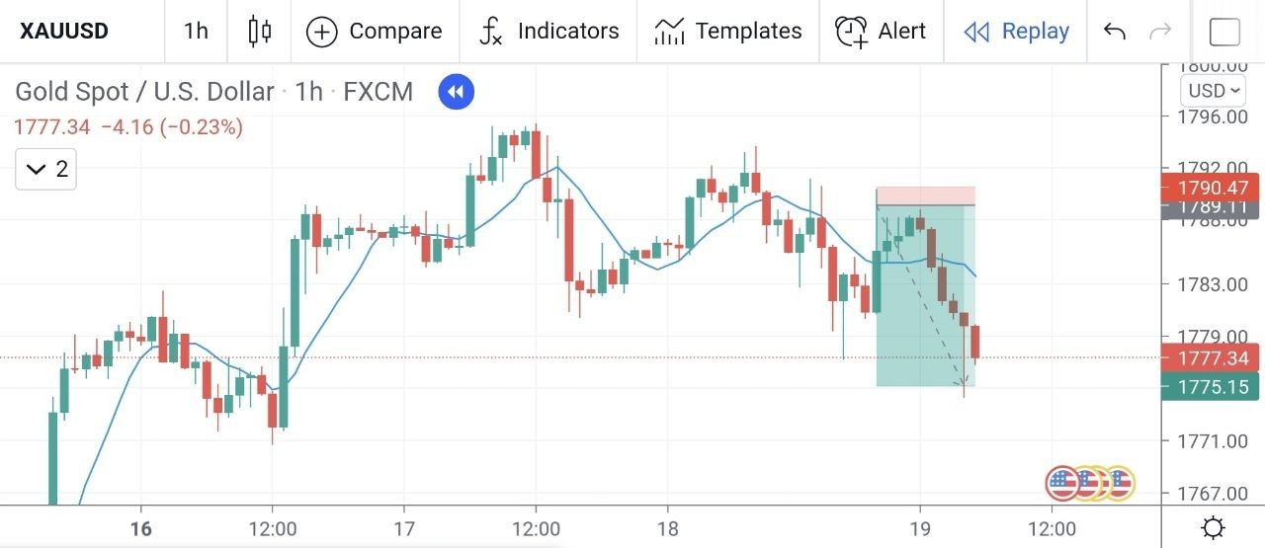

LESSON:06

News events
Remember liquidity? Well it plays a big part here. The start of the news event starts (shown by S) Price immediately moves up about 100 pips in the first 5 mins. We know that this has induced alot of liquidity into the market (everyone buying the big spike up) and also an imbalance which we have covered before. So we were looking to sell. Also we had an fu candle (another sign of manipulation so we knew the true intention behind this news event was to drop price).
This concept works on all news events and when you understand this it makes me laugh how easy and fun trading news events really is. You can find a whole weeks move in just an hour so it's amazing.
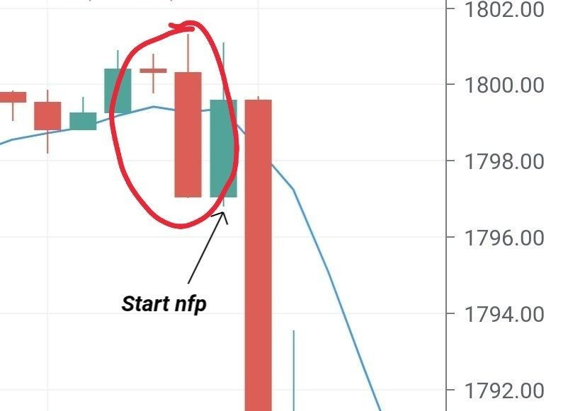
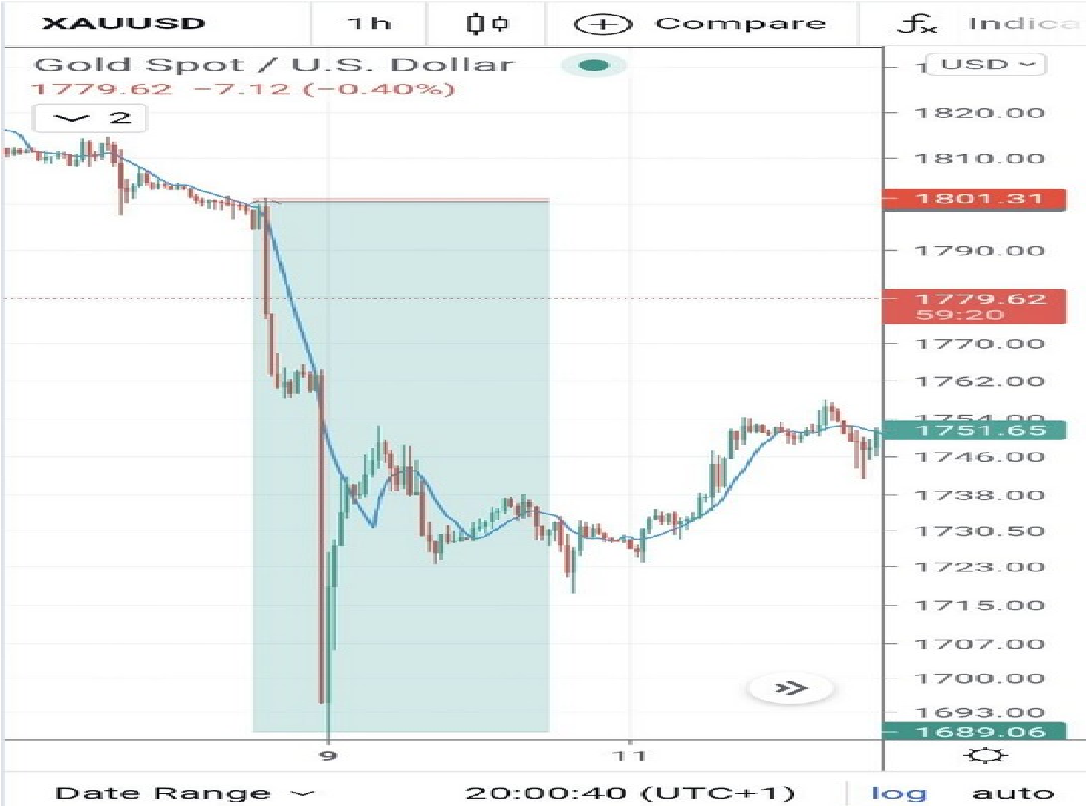
Look at nfp the trade that was a 1:47 risk to reward and for a 500 pip drop. Same concept. First we had price manipulate as highlighted -an fu scenario (check previous lessons).
And when the event started price first pushed up 20 pips tricking all the clueless traders to buy before this whopping drop.
Golden rule- Always wait for the manipulation it will always occur 100%.
Ps. This nfp trade actually went to 1:124 RR but It retraced very fast fast I only got a 1:47 RR.

LESSON:07

Risk to Reward and Risk Management

Blown accounts... im sure not even one trader ever became profitable before the markets gave them a rude awakening in the form of making you suffer by loosing all you have invested. The truth? It is simply impossible for you as a trader to ever "blow" an account (loose 100%).
This is why this is such an important subject - very much more so than any analysis and maybe this should have come first. ESPECIALLY to the new traders out there... remember the fundamental rule of the market! As stated in mark Douglas's trading in the zone (a must read) "Each moment in the market is unique" therefore no matter how good of an analyst you are... the possibility always remains that you can be wrong and loose the trade. Therefore risk per trade must be calculated.
If not? Then you are not a trader but rather a gambler (who will end up depressed becouse the market will take all you have).
This is where risk to reward comes in. We have already established that you must calculate risk per trade If you ever wish to be consistent yet just how much. One tip before we get into it - only think in terms of %. Not in amount of $ but rather % in relation to your total account balance.
This is best demonstrated with an example. You have a $1000 account. You decide you wish to risk 3% per trade ($30). Now you place a trade with a 30 pip sl for 90 pip reward (1:3 RR) if you accounted for risk you would use a 0.1 lot size (per 10 pip is $10 therefore 30 pips are $30). If you win you make $90
The same example. You have a $100 account and risk 3% ($30) this time you have a 3 pip sl. As you have a tight sl you use 1 lot size. And if you get 90 pips with this? That's $900. See now the power of risk to reward?
I know alot of you may understand this but you lack the understanding that % risk is always fixed per trade. It doesn't matter how many pip sl you have the % risk will never change. Start doing this and try to get higher risk fo reward trades? You will see insane gains on your account.

LESSON:08

Psychology

I know some people may have been expecting me to post this lesson on deeper analysis but the purpose of these lessons are not to please people- I can only guide you and this is possibly the most important lesson of all!
You have heard before I'm sure that 90% of all traders fail. Ever stopped to wonder why? How can it be that 9/10 people always loose? That statistic is really quite crazy. Knowing this people still invest into trading and ultimately become part of the 90%. What makes the 10% of winning traders different? Just one factor as Mark Douglas puts it beautifully " they have simply learnt to think different".
I know the majority of people in this channel really have no clue what it means to be a profitable trader. You have un realistic expectations and think trading is an overnight journey - that once you fix analysis everything will be amazing when the truth is that it really isn't that simple.
No matter how good of an analyst it doesn't matter at all if your psychology isn't right I can't stress this enough! There is a psychological barrier that each and every trader must break before you can become consistent winners.
Becouse thats what your ultimate aim is. Not to make profit one day and loose it another. You can NEVER have a blown account! Its just not possible! The only way this can happen is if you risk to much being greedy for fast profits. And let me tell you now... this industry has no space for greed the makrets will make you pay the price for your greed by stealing all your hard earned money.
You can not have any emotions while trading. Not happiness at wins nor sadness at losses. Ask yourself... if a trade hits stop loss will it impact you psychologically? If it does your risking too much. But if your a true trader and only risking 1% will it? No. You must do all you can to ensure that your emotions never show while trading.
I get so many messages from people wanting signals becouse you have lost money trading and think its the fault of analysis. While analysis plays a part the truth is that it was your own psychology that was bad and led to your failure not analysis.
So next time before you feel depressed about trading ask yourself... was this an issue of analysis (risking 1% you have to loose 100 trades in a row to ever blow an account) or was it an issue of psychology (did you risk 50% in a trade for example). Im sure the answer will be psychology for 99% of you.
Fortunately for you guys I have a solution. It's quite simple. Read "trading in the zone" by Mark Douglas. I have said it before and I will say it again. EVERY trader MUST read this book before you even consider trading as a profession. Everything stems from psychology and untill you master it you will never become successful in the forex industry.

LESSON:09

Market direction and insituonal orderflow

We have discussed in the previous lessons some powerful concepts that constantly repeat in the markets - however it is of no use if you are trading in the wrong direction completely hence why mastering orderflow is a must.
These lessons have been structured so that each lesson is connected to the last and as such, this concept will require all you have previously learnt to detmine true market direction.
First we start with the basic concept - retail support and resistance zones. Using this we can understand that price will break + retest every zone before moving to a further price point. We gain some information on future price direction - either by expecting a retest or a continuation to the next zone after a retest.
Then we have our insituonal zones. Price will not always perfectly react from these zones. However If we see a setup on lower timeframes and price gives a perfect rejection we know banks are in the move - and are most likely looking to move price to the next zone.
Liquidity... Liquidity.... where to start! If only everyone understood just how "overpowered" this concept is. Above all concepts you should focus on this (not saying the others should be neglected). Remember this golden rule "the market is always attracted to liquidity". Especially on gold and more volatile pairs it plays even more importance! Banks will always look to take out as many traders before making a true makret move - hence why if we follow where liquidity lies we know where price will come to in the future. Using this we understand more about market direction.
As for insituonal market flow...
Now price will always do one of three things.
- Hunt liquidity to the downside.
- Hunt liquidity to the upside.
- Consolidate and gather orders (banks are making their minds up about what to do next).
Using this information we know that price will always be in one of these states. What is ment by "orderflow change?" Simple. The answer is in the name - Banks have decided to stop targeting liquidity of one direction and will target another. (The higher the timeframe the slower it will take for its liquidity to be hunted) ALL timeframes must be considered but remember we look to target the most obvious liquidity (where retailers would place their sl).
That is one important concept to keep in mind. The second part to understanding orderlow is utilising FU candles. Especially strong FU setups (1hr TF +). When an FU forms it shows us that banks are comfortable with the liquidity left behind and are ready to move price in the next direction - generally the biggest sign of orderflow change. However just like the retail "break and retest" In order to be confirmed about market direction we must have an retest of the FU which holds. If it does we know that this is an insiutionally manipulated move (which we look to get in with - the true move).

LESSON:10

The truth of trading and why over 90% of traders loose money
In short trading is the hardest industry for anyone fo get into. Simply becouse you start non profitable - and its your job to change that into profitable. But at what cost? Trading quite literally "plays" with your emotions it brings out the worse qualities (fear, greed, anger, depression). Before starting trading seriously you must understand this. One the most strong mentally will succeed - there are no shortcuts. And sadly most traders when they start trading won't be prepared for this and blow accounts and loose large amounts of money.
For example if I was to give 100 people- totally new to trading - a $1000 account to trade with I can guarantee you - every single one of them would end up blowing the account at some point. They could make money luckily yes but overall would still loose it.
The point I'm trying to illustrate is... trading isn't easy. It does become like so at a point but you will start by loosing money! So understand that. And don't keep investing money only to loose it.
That is one factor. The other is that the markets are manipulated. Very much so. Without proper guidance most traders will fail (and are failing) just like banks want - becouse their startegys are widely known and stop losses easily visible. Remember... your wins are someone else's losses. It is the truth of the markets hence why banks need retail traders to "pledge" their money only so they can take it.
They know the common traders psychology (they have been doing this for a long time) and move price action with the intention to play with the common mind with utmost calculation to ensure the true move is hidden right to the end. It is actually a crime- the fact most of the trading community is kept in ignorance about the true extent of manipulation.
.
Honestly I wish I could say it differently and welcome everyone to start trading but the fact is its a sad industry. Its the reason its so publicy available- banks and brokers count on you to loose. Trading is a blessing but it is a curse for so many. And that's the dark truth. But the most disciplined and open minded will succeed but do you have what it takes to succeed.
I wish it was as easy as just finding a winning trade (signals) but its not! So much more is at play when trading and you can only understand this when you trade yourself. Finding a winning trade is only part of the play - how much do you risk? When do you close?
When do you breakeven? Etc. So signals will NEVER work. I challenge anyone to show me one month's consistency using signals - but you won't find it trust me.
This lesson is the most important. Everything must have a foundation and you can not just run into trading without knowing what you are getting yourself into. Trading is resolved around money. And you have heard I'm sure " money is the root of all evil" but the fact is... Money doesn't bring out the worse in people. Nor does it bring out the best. It just shows who you were all along. Which is why trading is such a powerful tool in self-development. It forces you to see your faults and the most determined will fix them and aim to progress daily - which will lead to their eventual success.

